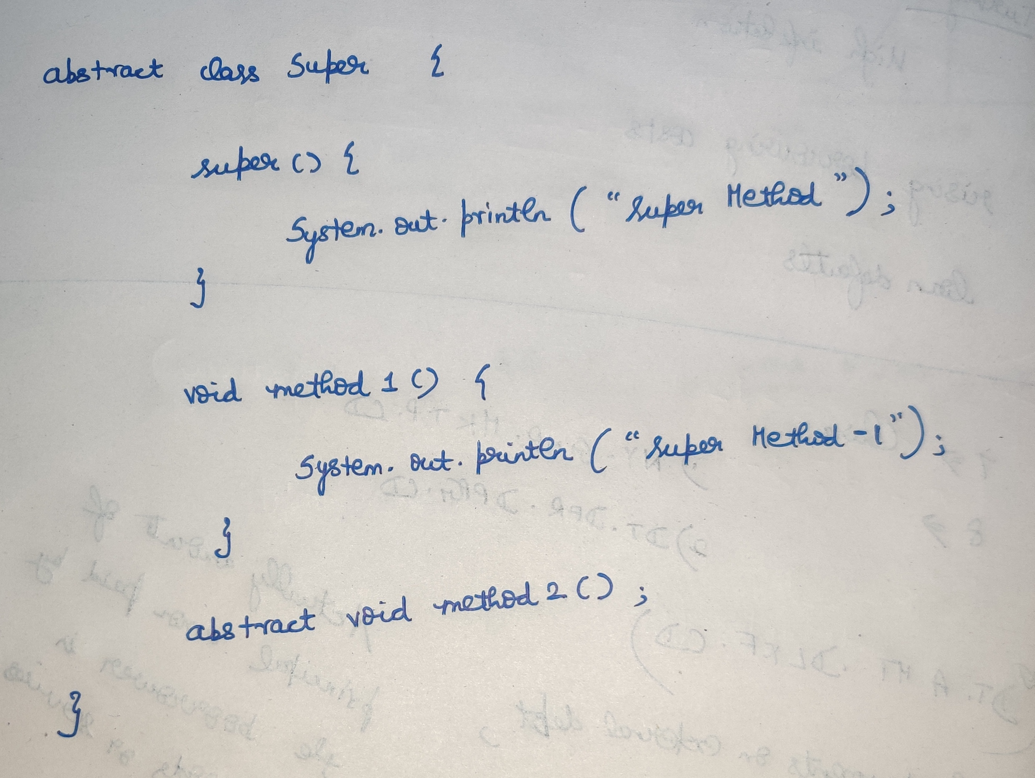 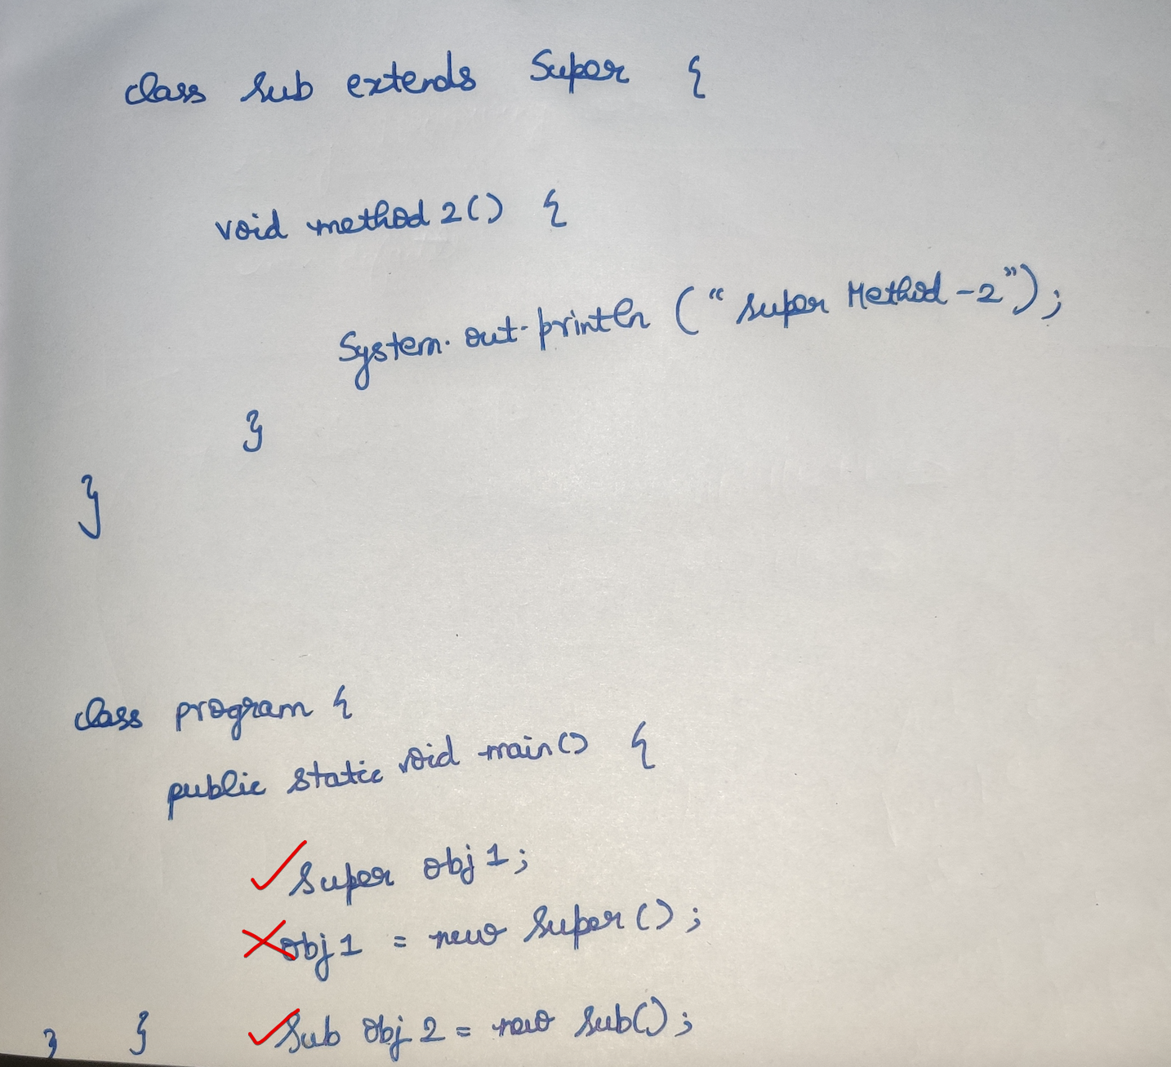

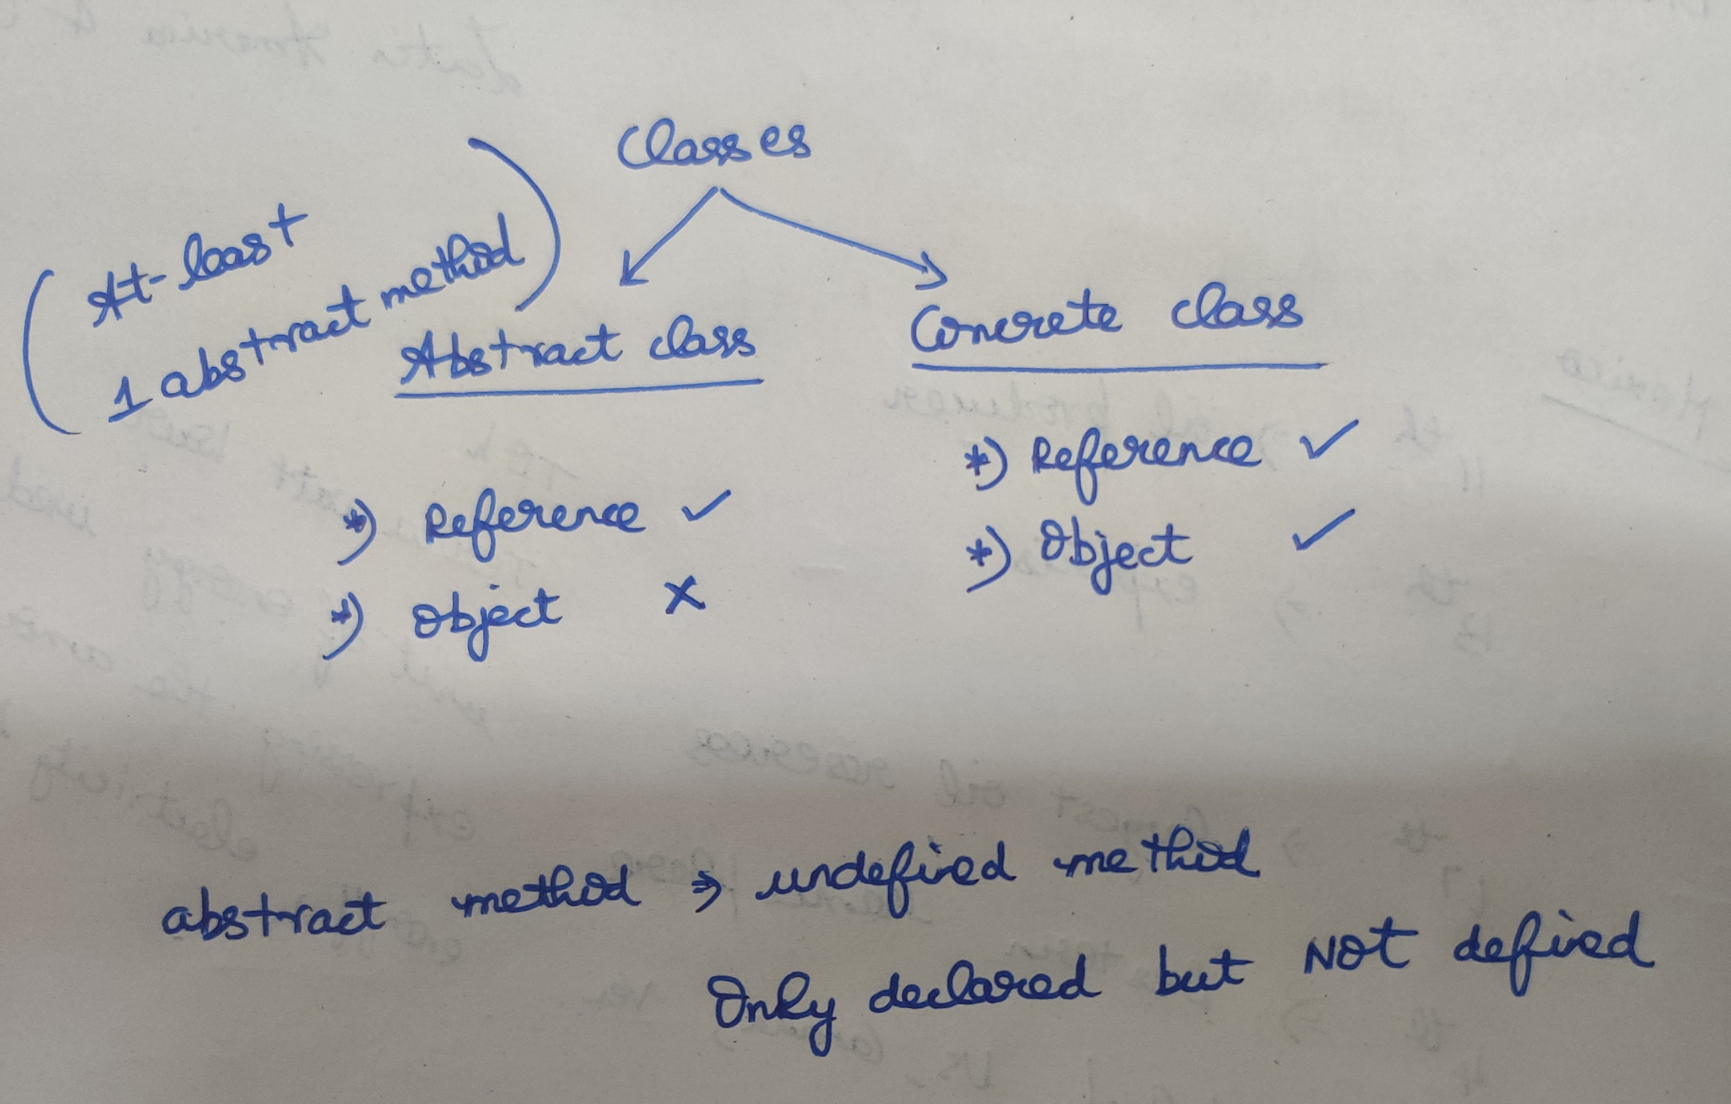

If a class is inheriting from an abstract class, then it will also become abstract class.  
To make that abstract class to concrete class it must over-ride all the abstract   
methods of the parent class.

Here Sub 🡪 abstract class if it doesn’t over ride Meth1()  
Sub 🡪 Concrete class since it over-rides Meth1(). Now object can be created.

We cannot create objects for abstract classes.

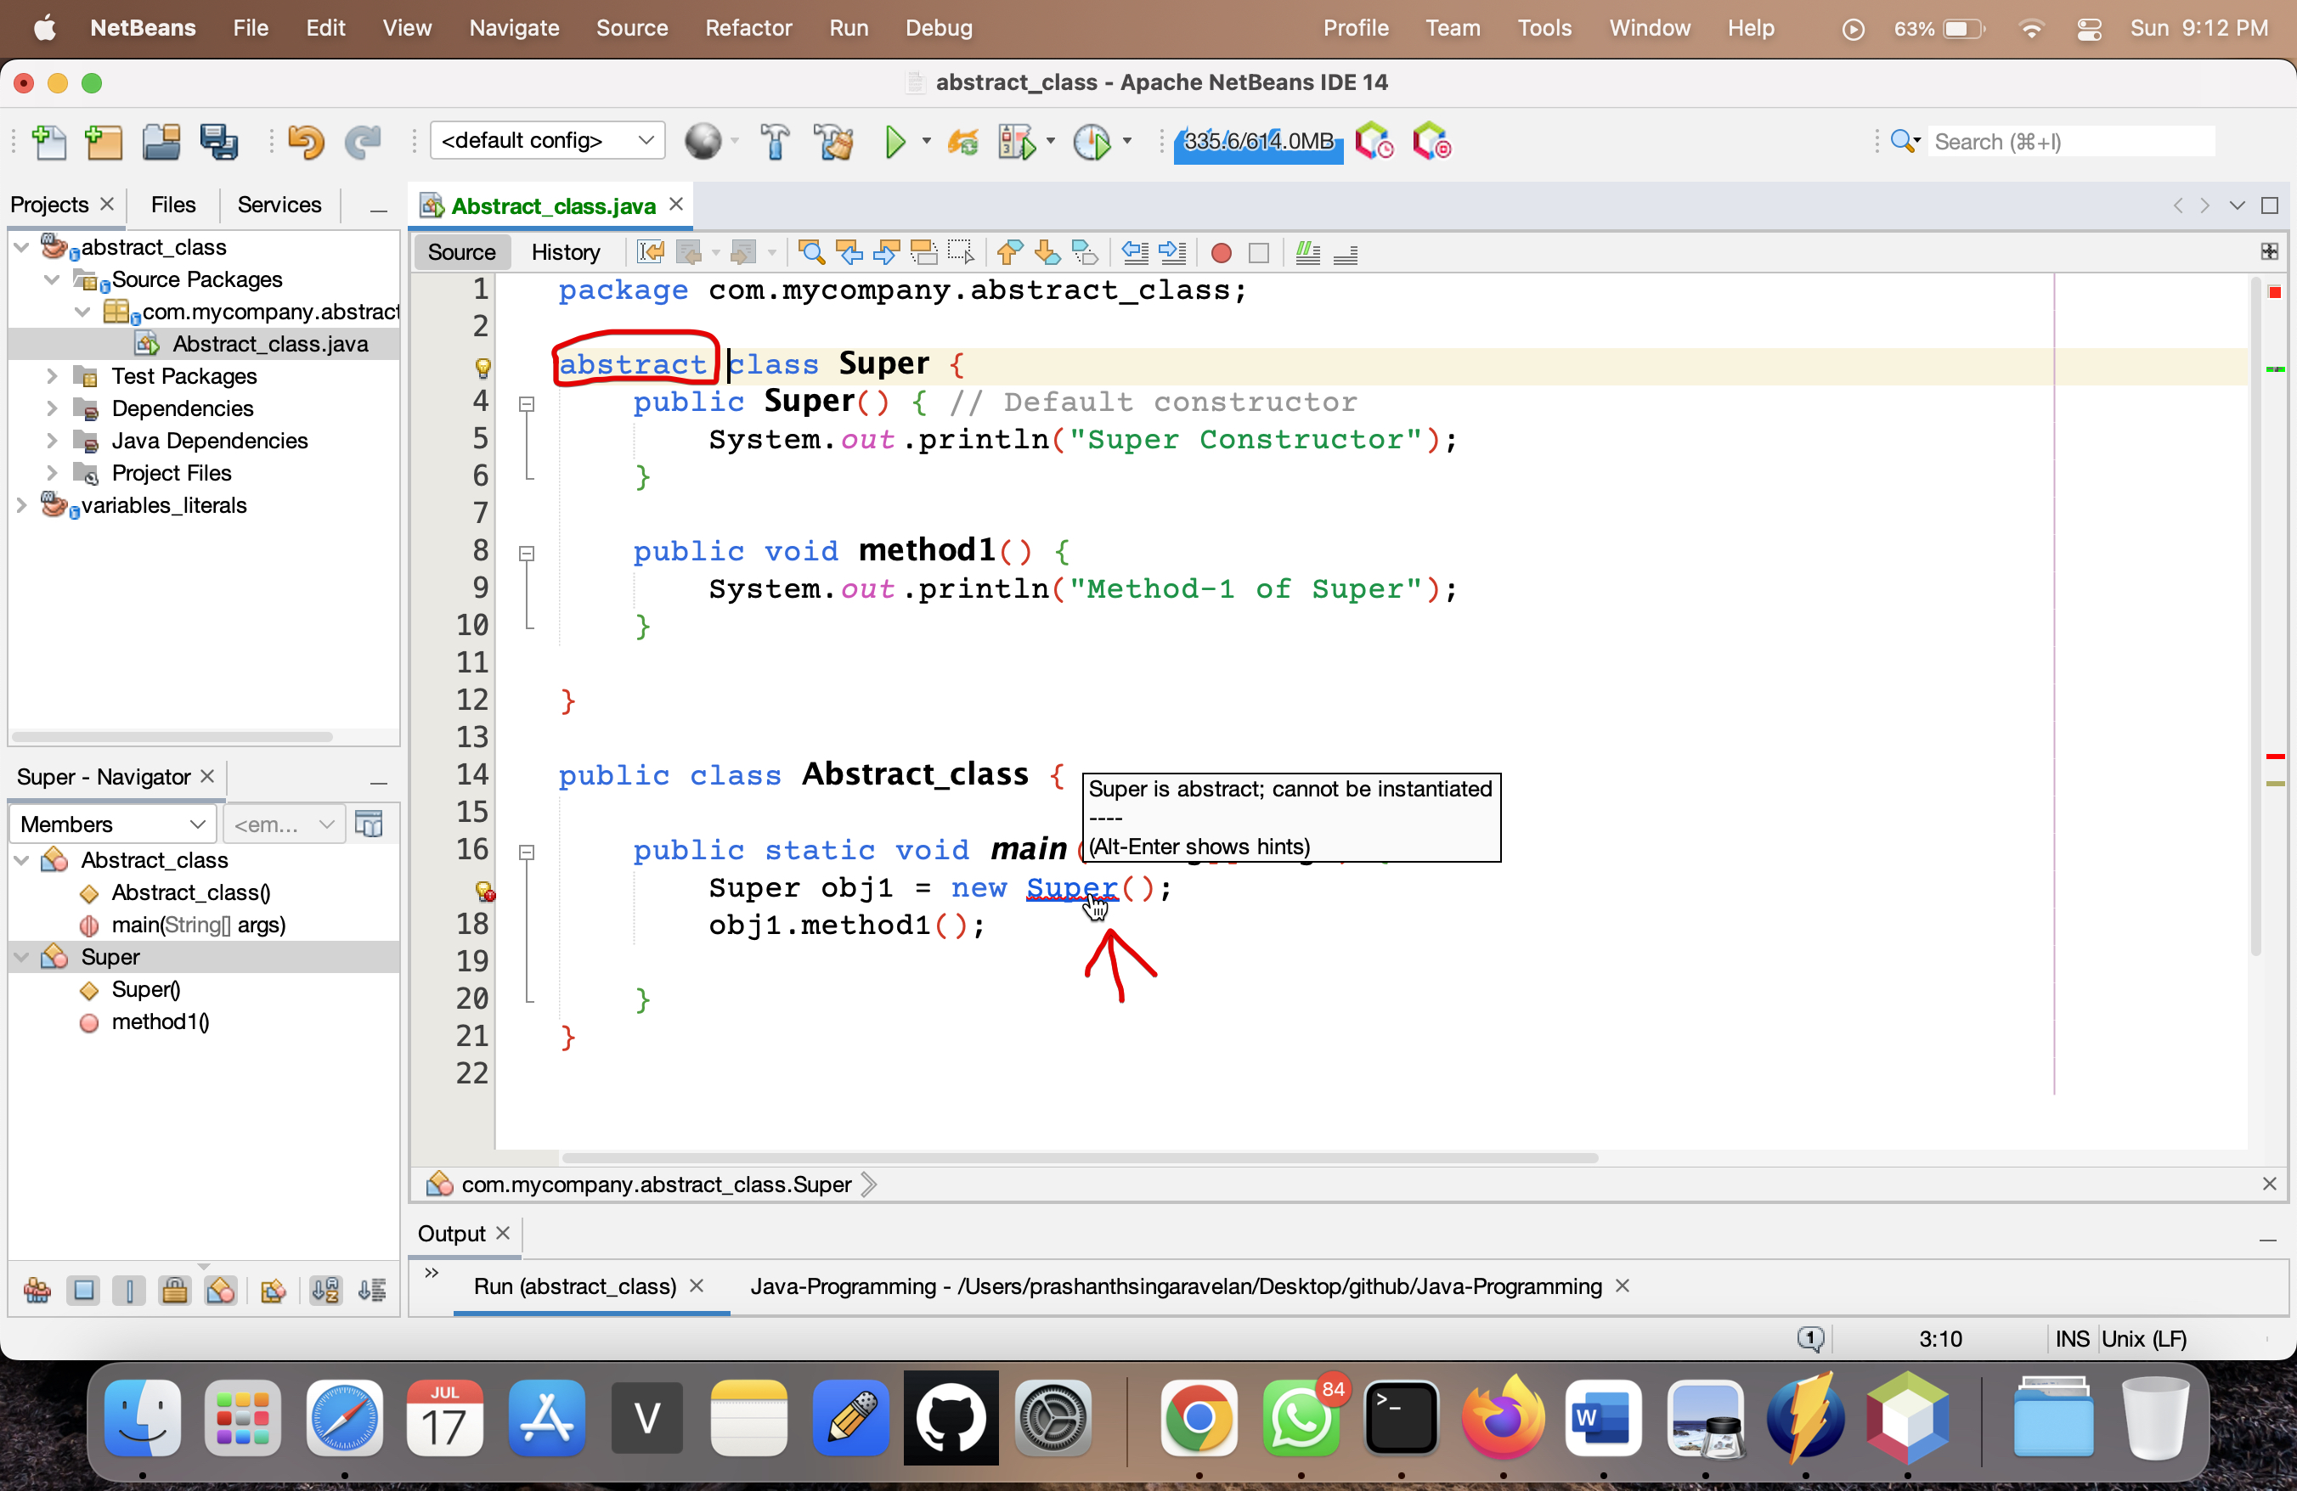

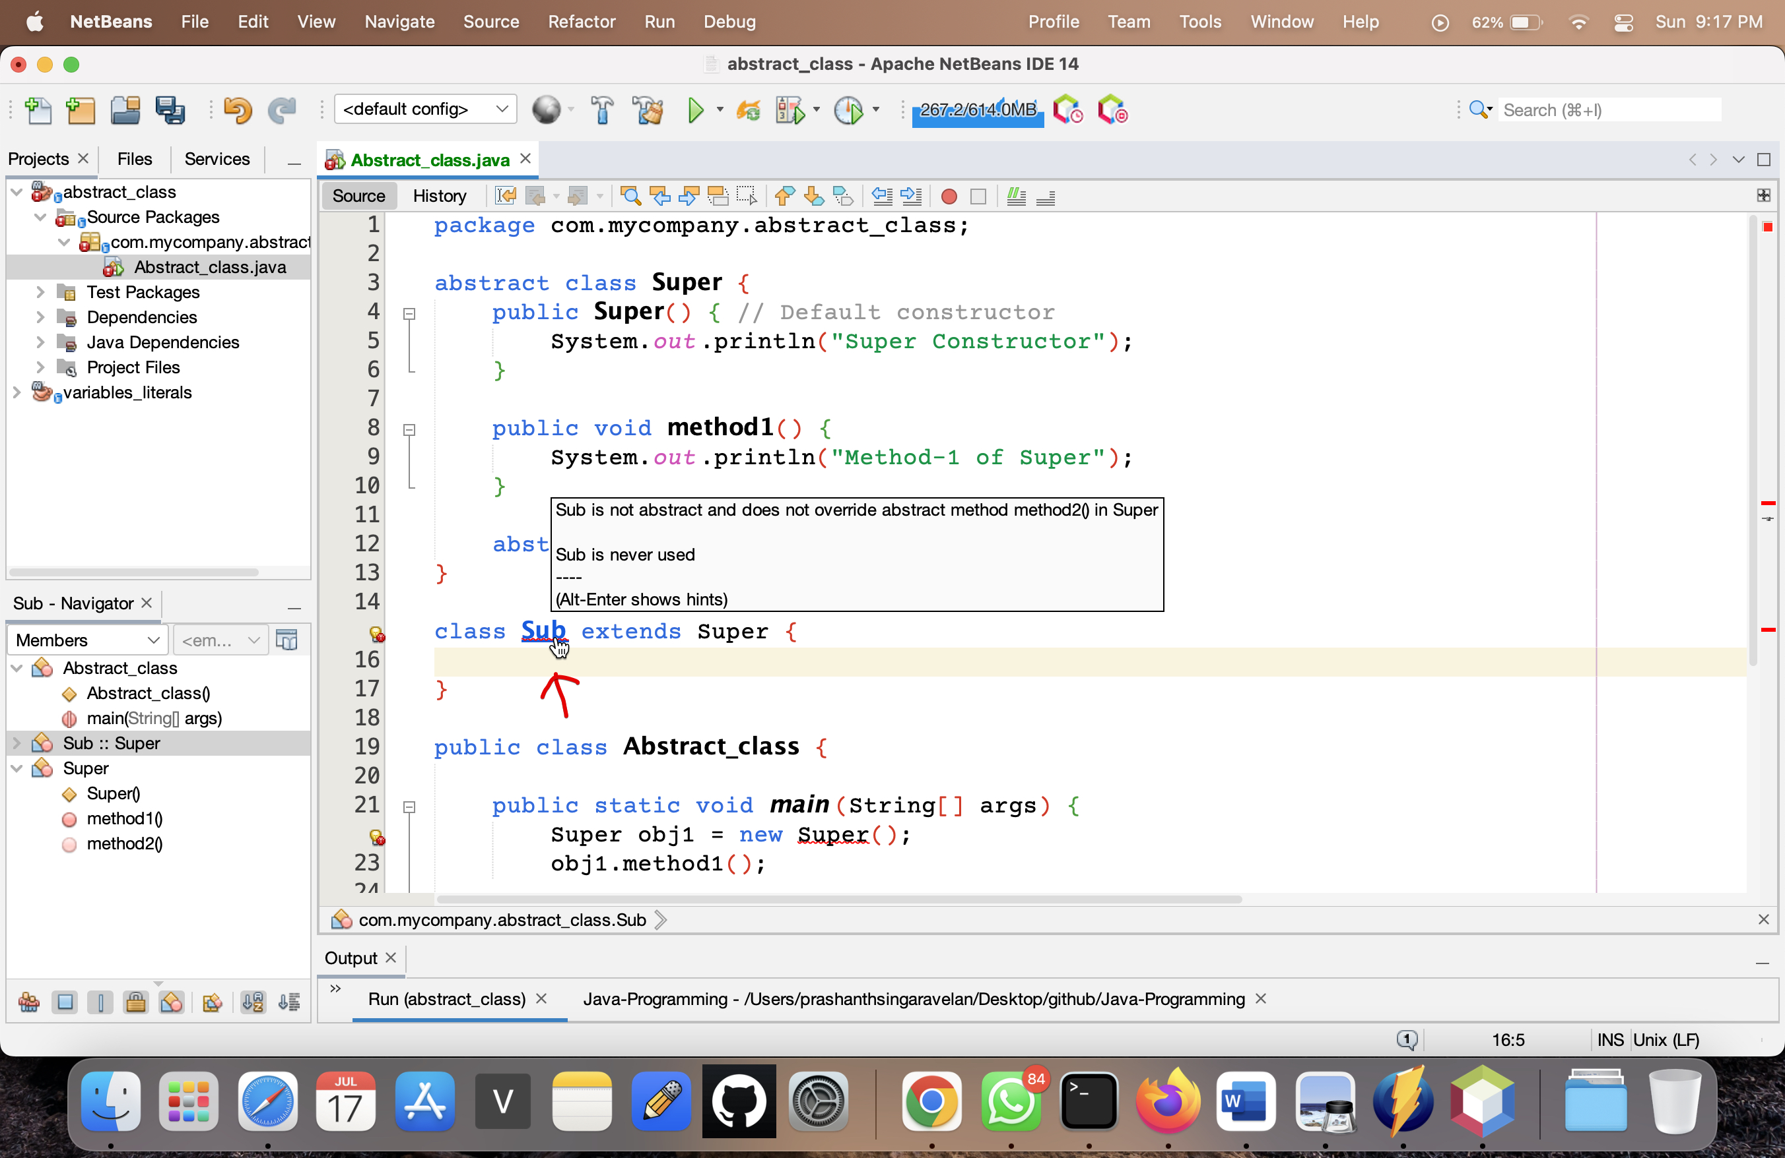

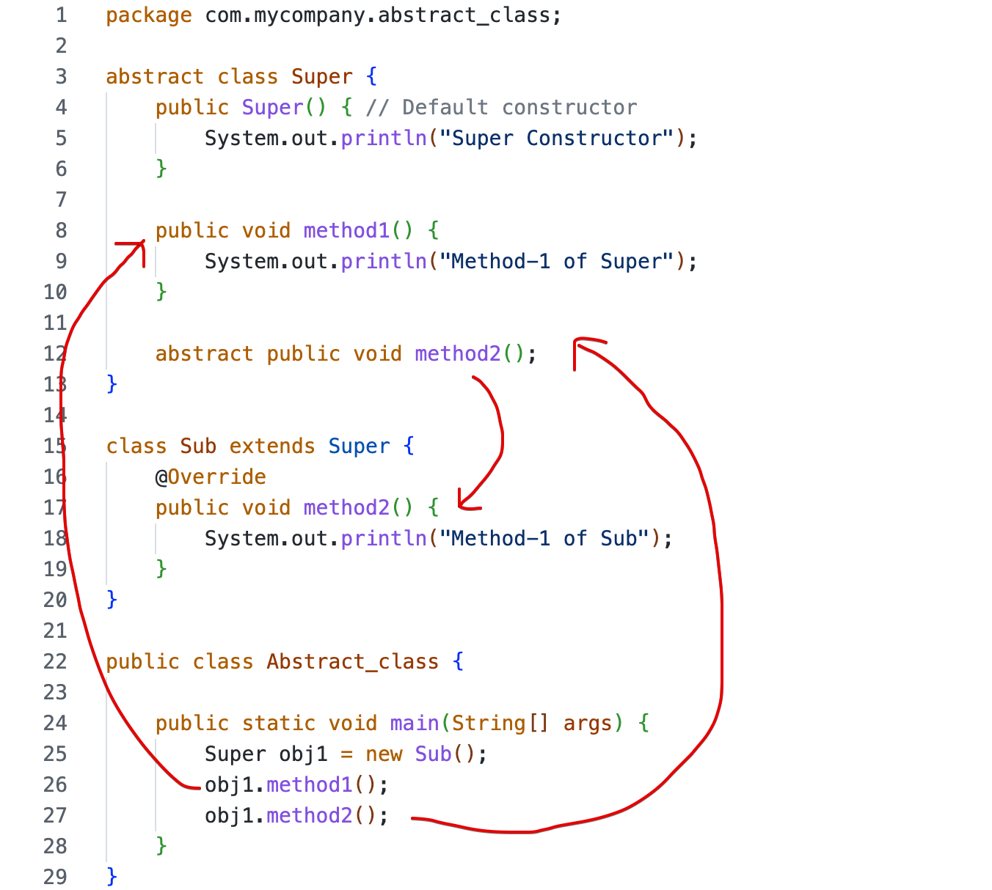

# **Practical example-1**

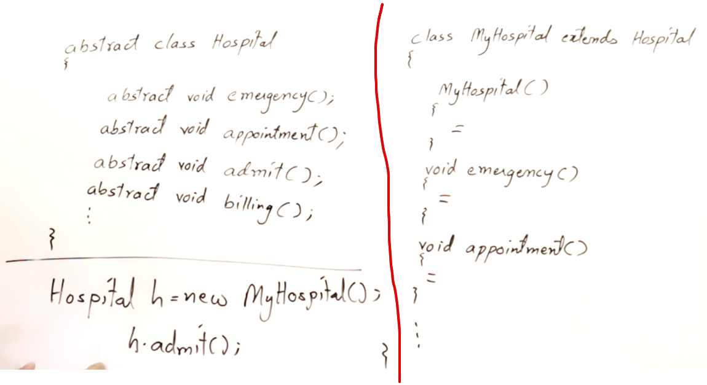

If I want to open a hospital I want to define all the functionalities of the class Hospital.  
After creating Hospital h object [means all the functions are defined properly], then MyHospital also here-after can be called as hospital.

So only we are defining h.admit()

# **Practical example-2**

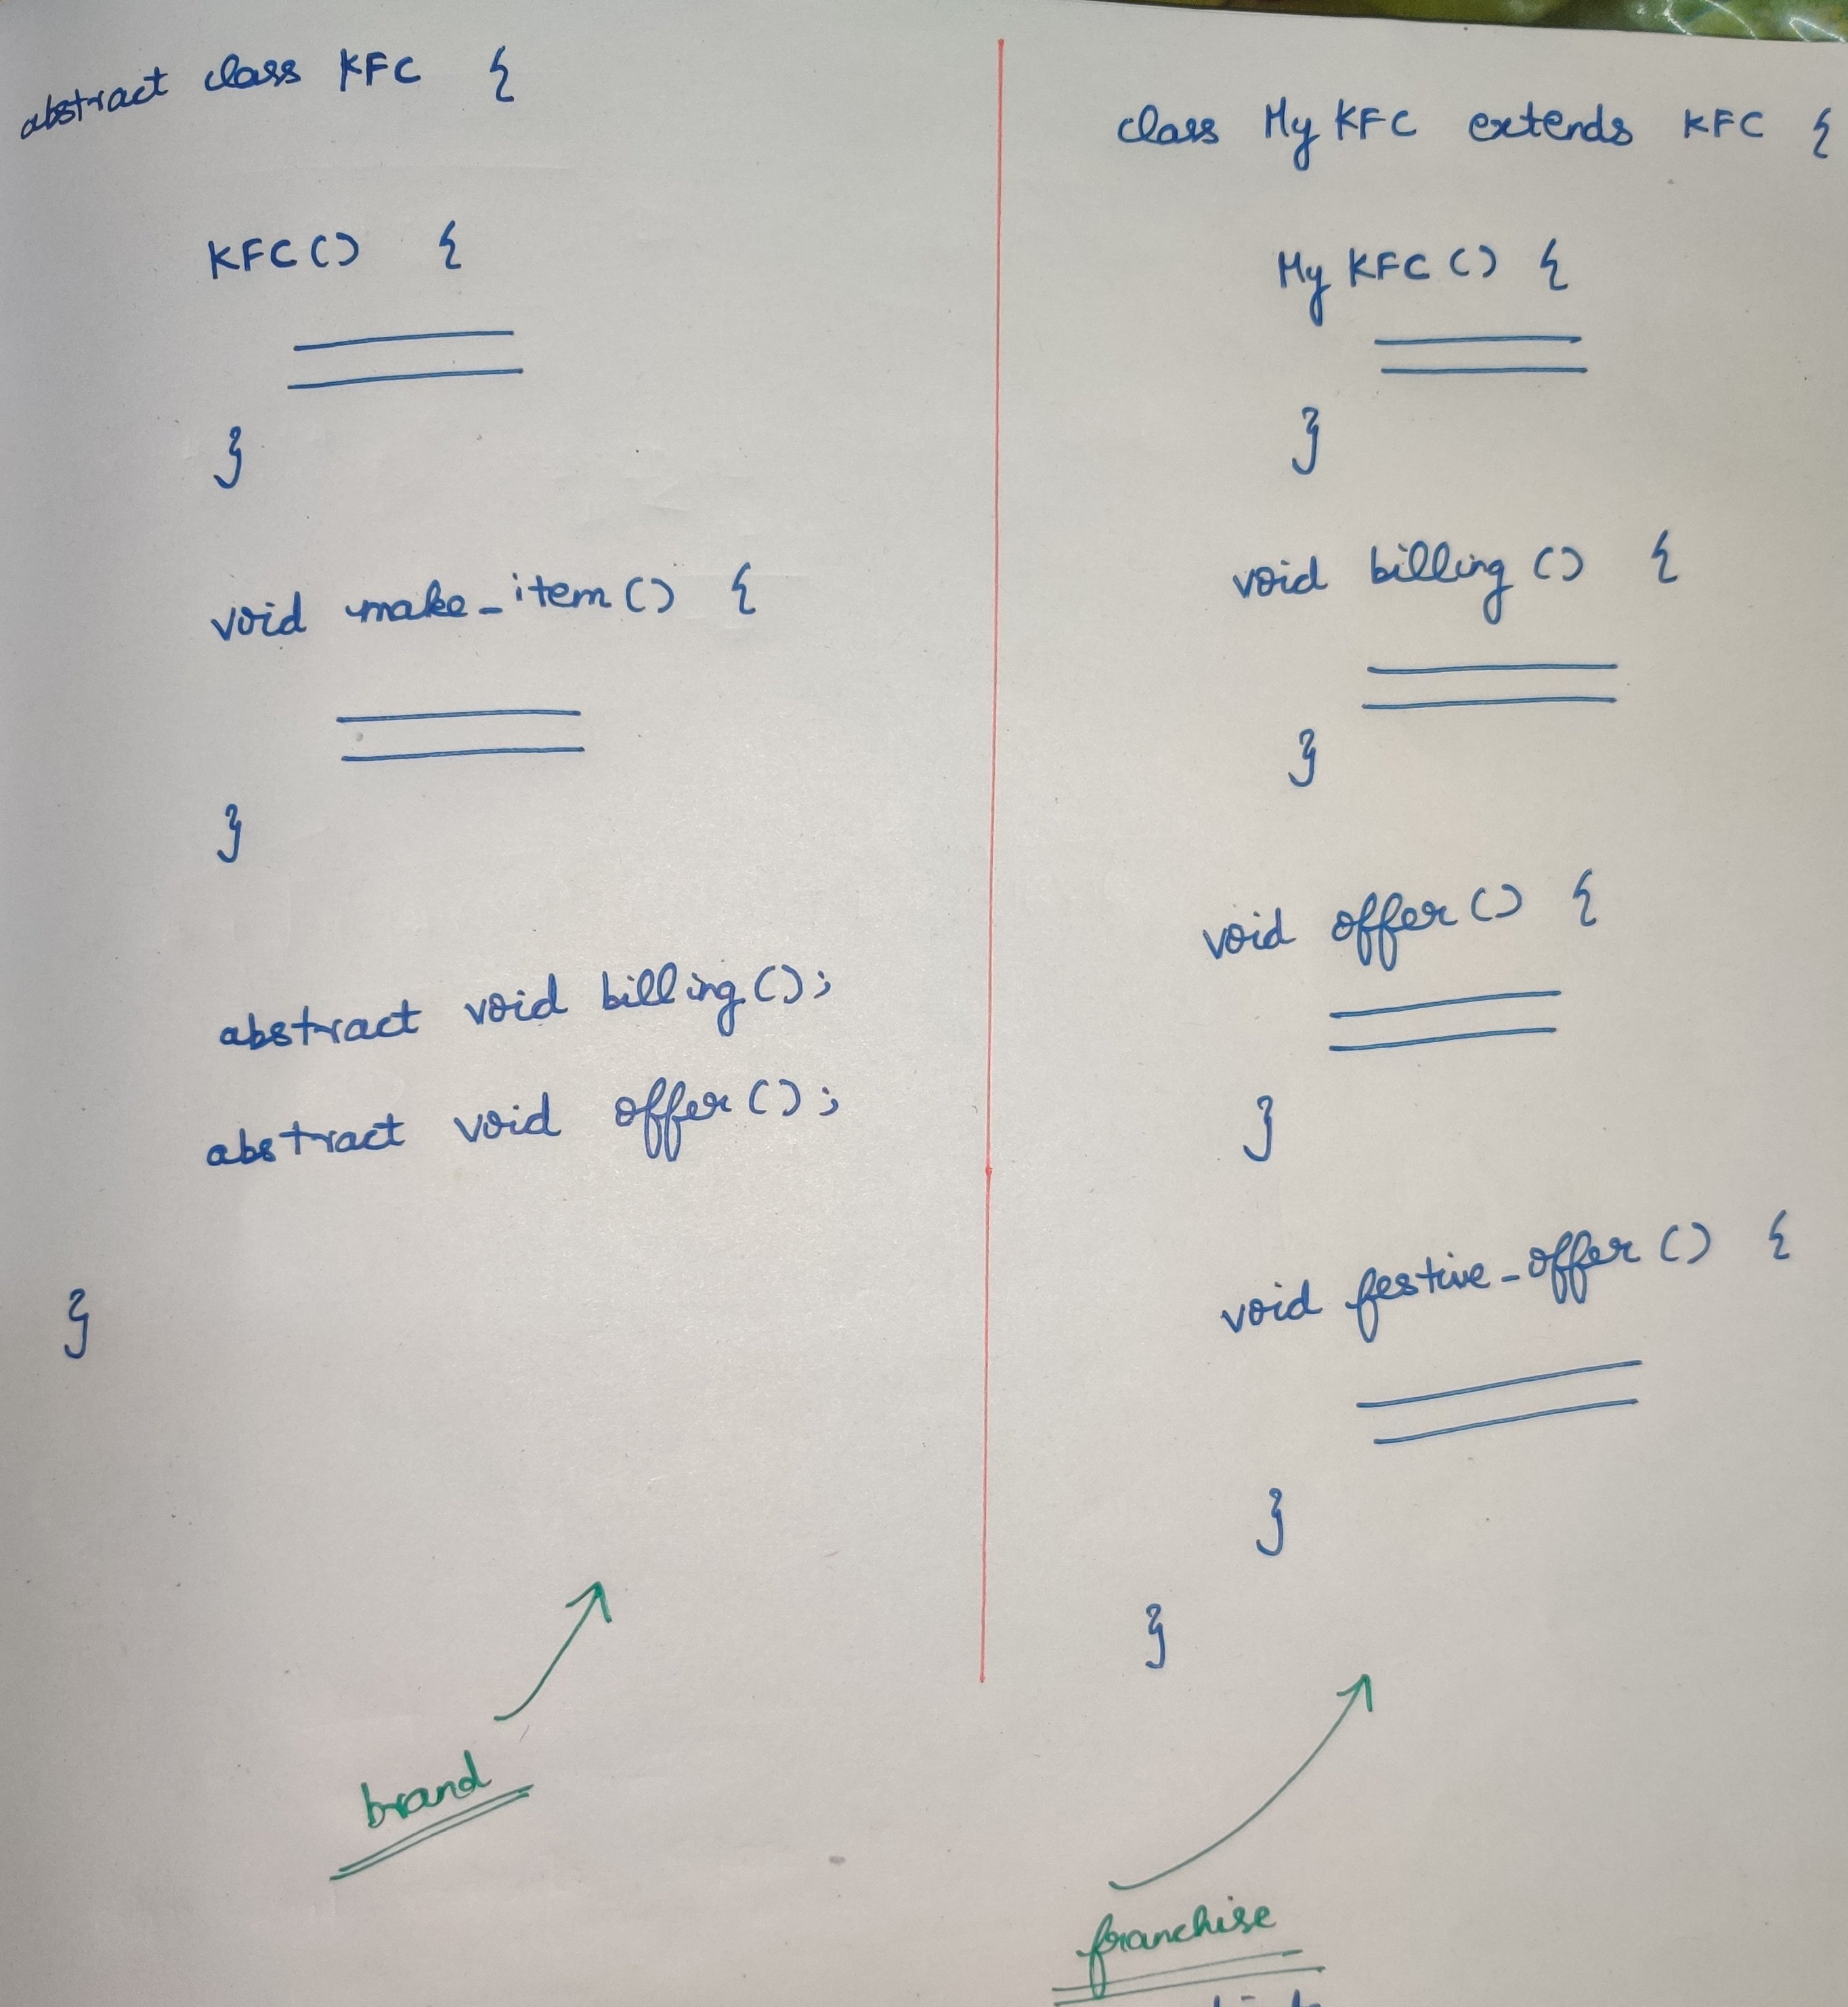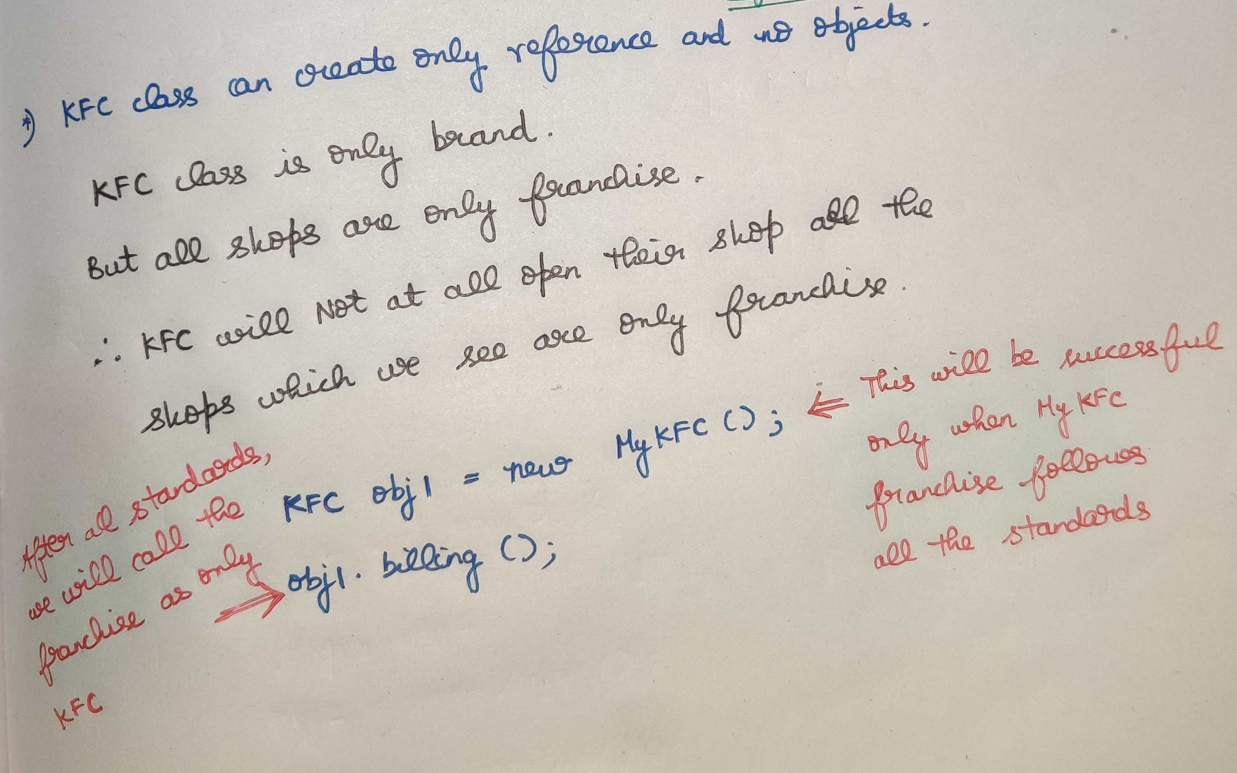

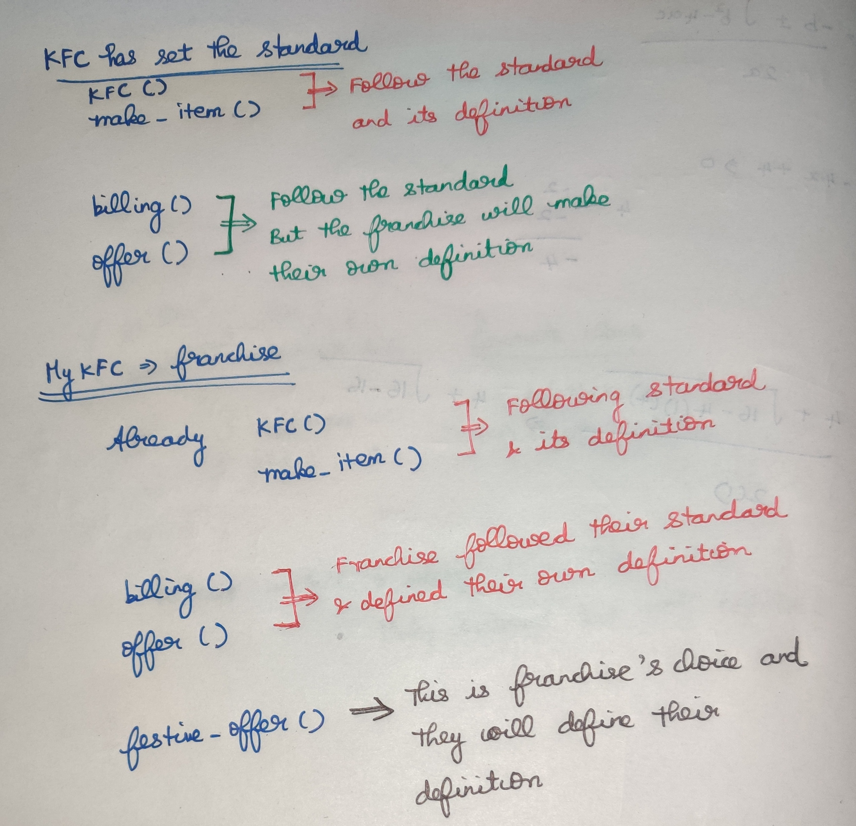

# **Practical example-3**

